MINI PROJECT REPORT
ON
“NEAR EARTH OBJECT RISK ANALYZER”

Submitted in partial fulfilment of the requirements for the award of degree of
Bachelor of Computer Applications (BCA)- 2 B

TO
UTTARANCHAL SCHOOL OF COMPUTING SCIENCES,
UTTARANCHAL UNIVERSITY, DEHRADUN



UNDER THE SUPERVISION OF: SUBMITTED BY:
Mr. DEEPAK KUMAR PANT TUSHAR KUMAR
UU2509000482

ACKNOWLEDGEMENT

We feel deeply thankful to God for blessing us with the strength and determination to successfully complete this project. We are also very grateful to our parents for their continuous support and encouragement throughout our studies at Uttaranchal University, Dehradun.
We would like to sincerely thank our project guide, Deepak Kumar pant, for his valuable guidance and help during this project. Without his support, this work would not have been possible.
We also thank all the teachers and staff of the Uttaranchal School of Computing Sciences for providing the facilities needed to complete this project. Finally, we express our gratitude to everyone who helped us directly or indirectly during this project.

TUSHAR KUMAR
BCA-2 B

DECLARATION

I hereby declare that this project work entitled “Near Earth Object Risk Analyzer” submitted by Rishabh Singh Pujara and Tushar Kumar to Uttaranchal Institute of Computing Sciences is an authentic record of our own work carried out at Uttaranchal University under the guidance of Deepak kumar pant.
This project has not been submitted elsewhere for any other degree or diploma.

TUSHAR KUMAR
BCA-2 B

CERTIFICATE OF ORIGINALITY

This is to certify that the project entitled “Near Earth Object Risk Analyzer” by Rishabh Singh Pujara and Tushar Kumar has been submitted in partial fulfilment of the requirements for the award of the degree of BCA-I from Uttaranchal University, Dehradun. The results embodied in this project have not been submitted to any other University or Institution for the award of any degree.

Under the guidance of:
Mr. Deepak Kumar pant
Associate Professor (USCS)
Uttaranchal University, Dehradun

TABLE OF CONTENTS

S NO. | TOPIC | PAGE  NO.
1. | Front Page | 1
2. | Acknowledgement | 2
3. | Declaration | 3
4. | Certificate of Originality | 4
5. | Table of Contents | 5-6
6. | Introduction | 7
7. | Objectives | 8
8. | Hardware and software requirements | 9
9. | System Analysis | 10-12
10. | Identification of need | 13
11. | Preliminary Investigation | 14
12. | Feasibility Study | 15
13. | Project Planning | 16
14. | Project Scheduling:  - Gantt Chart  - Pert Chart | 17-19
15. | Software Required Specifications (SRS) | 20-23
16. | Data Flow Diagram  - Level 1  - Level 2 | 24-25
17. | Control Flow Diagram | 26
18. | Class Diagram | 27
19. | Use Case Diagram | 28
20. | Testing | 29-31
21. | Future Scope | 32
22. | Implementation (Code) | 33-37
23. | Bibliography | 38

INTRODUCTION

A Near-Earth Object (NEO) Risk Analyzer is a system designed to analyse asteroids that come close to Earth. These object scan be potential risks if their orbits bring them too close to Earth’s orbit. Monitoring such objects is important for understanding possible impact threats.
Now a day, space agencies collect large amounts of asteroid data through telescopes and observation systems. Organizations such as NASA provide public database APIs that contain information about asteroid size, velocity, and distance from Earth. But, manually analysing this large amount of data can be difficult and time-consuming.
To counter this problem, automated systems like a NEO Risk Analyzer help process and understand asteroid data more efficiently. By fetching information from the NASA’s Near-Earth Object API, the system can analyse and estimate the potential risk of different asteroids.
The system uses algorithms that evaluate factors such as asteroid’s diameter, velocity, and distance from Earth to determine whether an asteroid could be dangerous. The results are then displayed using charts to make the information easy to understand.
This project aims to develop a simple NEO Risk Analyzer that automatically receives asteroid data, performs risk calculation, and presents the results through a user interface. The system helps simplify asteroid risk analysis and demonstrates how automated tools can support space research and monitoring.

OBJECTIVES

- Develop a Python application that analyses asteroid data obtained from NASA's NEO API and visualizeits data using graph and GUI.

Secondary Objectives:
- Retrieve real-time asteroid data
- Display asteroid data
- Display results in graphical interface
- Identify potentially hazardous asteroids
- Provide user-friendly visualization

HARDWARE AND SOFTWARE REQUIREMENTS

1. Hardware Requirements
- Computer/Laptop → to write, compile, and execute the Python program.
- Keyboard and Monitor → for inputting password length and viewing the output.
- Processor → Intel/AMD processor (any basic configuration is acceptable).
- RAM → Minimum 2 GB RAM (4 GB or more recommended).
- Storage → At least 100 MB of free space for saving code and executables.

2. Software Requirements
The software requirements for designing and testing the project are as follows:
- Python Compiler → Dev C++ or any other compiler to compile the C program.
- Operating System → Windows, Linux, etc.
- Terminal/Command Line → To run the compiled program.
- Python libraries: NumPy, Pandas, Matplotlib, Tkinter, Datetime etc..

SYSTEM ANALYSIS

System analysis explains how the Near-Earth Object (NEO) Risk Analyzer works. The system receives asteroid data from the NASA’s Near-Earth Object API, analyses the potential risk of asteroids, and presents the results through visualizations and a user interface. The goal of the system is to automate asteroid data analysis and help identify potentially hazardous asteroids.

- Existing Asteroid Monitoring Systems
Several international organizations monitor asteroids and near-Earth objects.
- NASA tracks near-Earth asteroids and provides public data through APIs.
- Jet Propulsion Laboratory operates the Sentry Impact Monitoring System.
- European Space Agency runs the NEO Coordination Centre for asteroid observation.

- Limitations of Manual Data Analysis
Manual analysis of asteroid data has several challenges:
- Large datasets are difficult to process manually.
- Human errors may occur during calculations.
- Raw data is difficult to interpret without visualization.

- Benefits of Automated Risk Analysis
The proposed system provides several advantages:
- Faster processing of asteroid data
- Automatic retrieval of updated information from NASA
- More accurate calculations with reduced human error
- Clear visualization of asteroid risk levels

- Architecture of the Proposed System
The system follows a modular architecture where each module performs a specific task.

- Data Retrieval Block:
This module collects asteroid data from the NASA NEO API.
- Sends requests to the NASA API
- Retrieves asteroid information in JSON format
- Extracts relevant data such as size, velocity, and distance

- Risk ExtractionBlock:
This module analyses asteroid parameters to determine the potential threat level.
It considers factors such as:
- Asteroid diameter
- Relative velocity
- Distance from Earth
Risk levels can be compared using scientific scales like the Torino Scale.

- Visualization Block:
The visualization module converts asteroid data into graphs and charts.
- Asteroid size distribution charts
- Distance vs velocity graphs
- Risk level charts

- User Interface Block:
The user interface allows users to interact with the system.
- Dashboard displaying asteroid data
- Charts and visualizations
- Tables showing asteroid parameters

IDENTIFICATION OF NEED

Near-Earth Objects (NEOs), like asteroids, can be hazardous towards Earth. Space agencies like NASA collect large amount of data on asteroid’s size, distance from Earth, and velocity.
Analysing this data can be difficult, time-consuming and can harbour human errors. Students, researchers, and scientists need simple and easy-to-understand tools to interpret this data (asteroid’s data) and evaluate potential risks as soon as possible.
Our system NEO Risk Analyzer tackle this need by automatically receiving data from the NASA’s NEO API, calculating risk levels, and presenting results in an easy-to-understand User Interface, enabling fast andreliable identification of potentially hazardous asteroids.

PRELIMINARY INVESTIGATION

Before development, we conducted research to ensure that the system could fetch required asteroid data to calculate risks accurately using a proper scientific algorithm, and present the results on a user-friendly dashboard. The goal was to identify dependable data sources, programming tools, and proven scientific methods for calculating asteroid threats.
Key Findings:
- NASA’s NEO API – Provides real-time information on near-Earth objects, including their size, velocity, and how close they are to Earth.
- Python Libraries – requests for API calls, pandas and NumPy for data processing and calculations, and matplotlib for creating visualizations.
- Tkinter GUI – Allows the creation of interactive dashboards where users can input parameters and view asteroid data and risk visualizations.
- Risk Assessment Methods – Guided by research on probabilistic modeling and simulation-based approaches for evaluating asteroid impact risks.

Research Papers Informing Risk Calculations:
- Asteroid Risk Assessment: A Probabilistic Approach – Jason C. Reinhardt, Xi Chen, Wenhao Liu, Petar Manchev, M. Elisabeth Paté-Cornell
Introduces probabilistic models to quantify asteroid impact risk while considering orbital uncertainties.
- Impact Probability Computation of Near-Earth Objects using Monte Carlo Simulation – Matteo Romano, Matteo Losacco, Camilla Colombo, Pierluigi Di Lizia
Demonstrates the use of Monte Carlo simulations to estimate impact probabilities by generating many potential asteroid trajectories.

FEASIBILITY STUDY

The feasibility study evaluates whether the NEO Risk Analyzer project is practical in terms of technical implementation, cost, and user operation
1. Technical Feasibility
- Python for API integration – Can receive data from NASA’s API using requests library.
- Tkinter allows GUI development – A Python library used for making user interface for easy access for users.
- NASA provides free API access –Real-time and reliable asteroid data available for free on NASA’s official website.
These factors confirm that the project can be implemented successfully and free of cost using widely available technical tools.
2. Economic Feasibility
- No cost software – Python and Tkinter are free to use.
- Open-source tools – Libraries like requests, pandas, and matplotlib are free and widely supported.
- NASA’s NEO API – Free to use API provided by NASA.
The project requires zero economic investment, making it economically feasible to develop.
3. Operational Feasibility
- Easy-to-use interface –User can view asteroid data and its risk analysis effortlessly.
- Minimal user training required – Easy to understand dashboard and clear visualizations ensure that user can use the system effectively.

PROJECT PLANNING

1. Requirement Analysis
In this phase, the project requirements are identified. The system will need to retrieve asteroid data from NASA’s API, analyse potential risks, and present results in a clear and user-friendly format. The inputs, outputs, and main system features are defined in this stage.

2. GUI Design
A graphical interface will be designed using Tkinter. The interface will allow users to view asteroid data, risk results, and charts in a simple dashboard.

3. Risk Algorithm Design
A risk calculation method will be developed using asteroid parameters such as diameter, velocity, and distance from Earth. The algorithm will evaluate these values to determine the potential risk level of each asteroid.

4.Implementation
During implementation, the system modules will be developed using Python. The program will fetch data from the NASA API, process asteroid information, calculate risk levels, and display the results in the user interface.

5. Testing
Finally, the system will be tested to ensure all modules work correctly. The API integration, risk calculations, and user interface will be verified for proper functionality.

PROJECT SCHEDULING

The NEO Risk Analyser project is scheduled over a period of four weeks with a structured approach to ensure smooth development and timely completion. The first week is dedicated to requirement analysis, where the project scope, user inputs, and data retrieval using the NASA NEO API are defined. In the second week, system design is carried out, including architecture planning and UML diagrams. The coding phase spans weeks two and three, where the user interface, API integration, and radar chart visualization using Matplotlib are implemented. Testing is performed in the fourth week to validate functionality and fix errors, while documentation is maintained throughout all stages. Finally, a presentation is prepared over the weekend to demonstrate the project effectively.

Key Points:
- Requirement Analysis → Week 1
- System Design → Week 2
- Coding → Weeks 2–3
- Testing → Week 4
- Documentation → Continuous
- Presentation (PPT) → Final Weekend
- Total Duration → 5 Weeks

PERT CHART
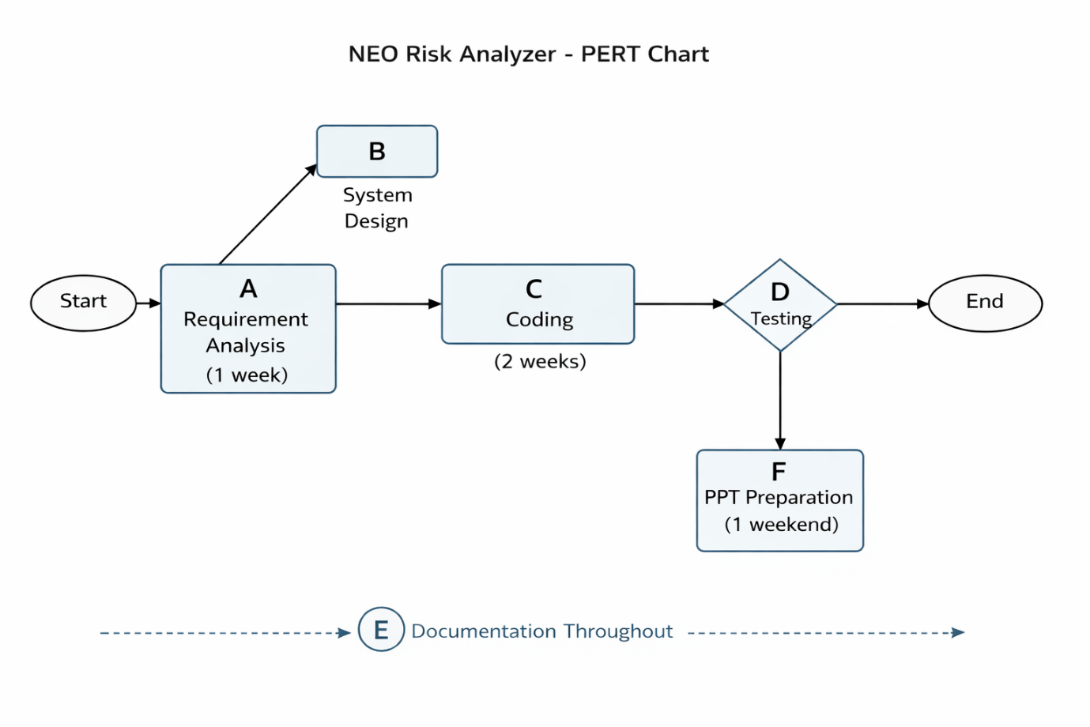

GANTT CHART
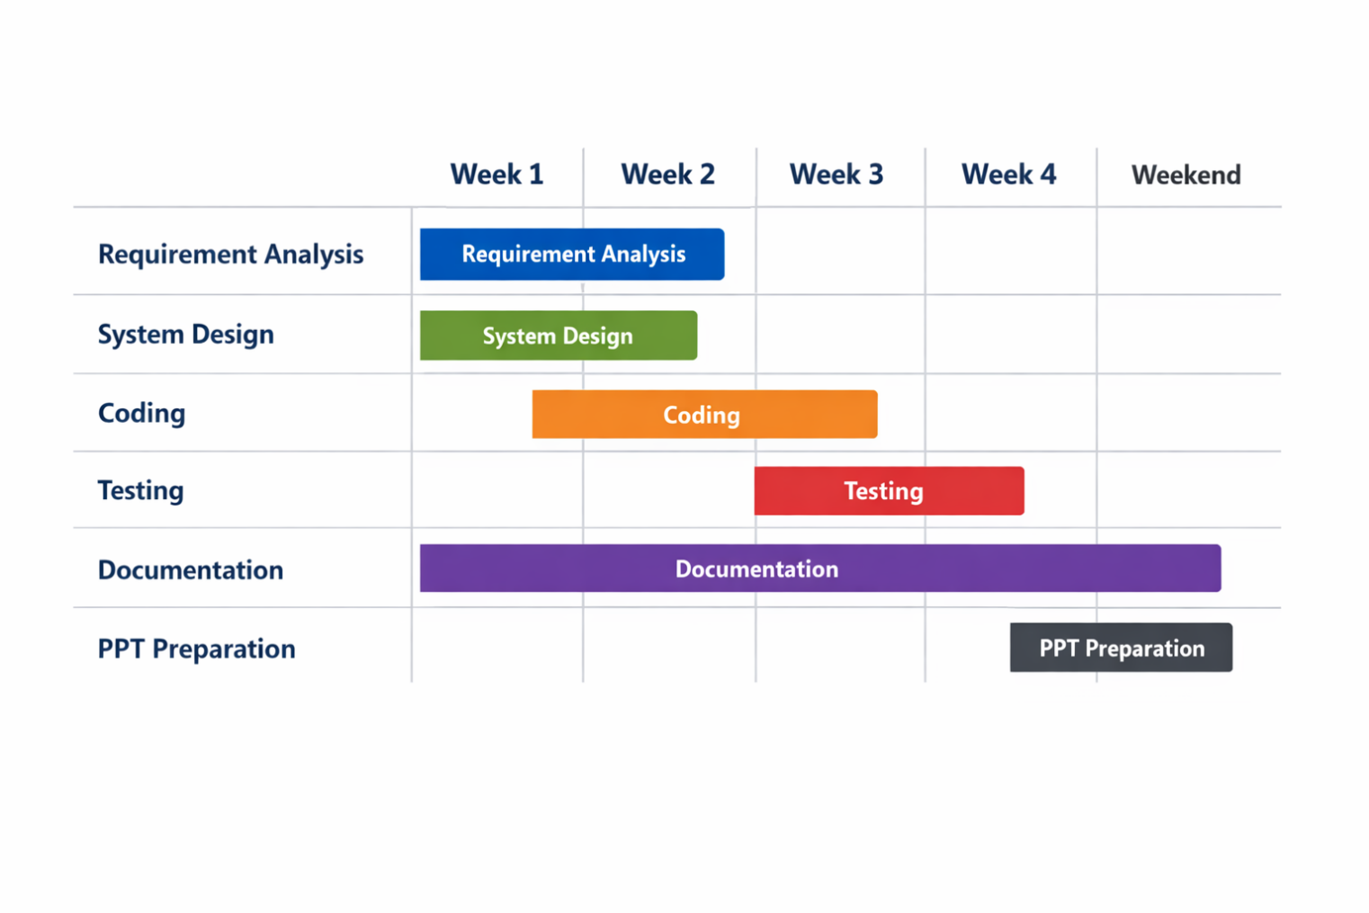

SOFTWARE REQUIREMENT SPECIFICATIONS (SRS)
1. Introduction
1.1 Purpose
The purpose of this system is to retrieve asteroid data from the NASA Near Earth Object (NEO) API, process the data, and visualize it using a radar chart in a desktop application.
1.2 Scope
The application allows users to:
- Search asteroids by date
- Select a specific asteroid
- View detailed asteroid data
- Visualize data using a spider plot
The system is built using:
- Python
- Tkinter (GUI)
- Matplotlib (Visualization)
1.3 Definitions
- NEO: Near Earth Object (asteroid close to Earth)
- API: Application Programming Interface
- Spider Plot: Radar chart showing multi-variable data

2. Overall Description
2.1 Product Perspective
This is a standalone desktop application that interacts with an external API (NASA NEO API).
2.2 Product Functions
- Accept user input (date)
- Fetch asteroid data from API
- Extract useful parameters
- Display asteroid list
- Show details of selected asteroid
- Generate spider plot visualization
2.3 User Characteristics
- Basic computer knowledge
- No technical expertise required
2.4 Constraints
- Requires internet connection
- Dependent on API availability
- Limited by API rate limits

3. Functional Requirements
3.1 User Input Module
- User can enter a date
- System validates date format
3.2 API Request Module
- System sends request to NASA NEO API
- Retrieves asteroid data in JSON format
3.3 Asteroid Selection
- System displays list of asteroids
- User selects one asteroid
3.4 Data Extraction
System extracts:
- Diameter
- Velocity
- Miss Distance
- Hazardous status
3.5 Data Processing
- Normalize values for visualization
- Prepare structured dataset

3.6 Visualization Module
- Generate spider (radar) plot using Matplotlib
3.7 Display Module
- Show asteroid details
- Display graph in Tkinter window

4. Non-Functional Requirements
4.1 Performance
- Data retrieval within 2–5 seconds
- Smooth UI interaction
4.2 Usability
- Simple and intuitive interface
- Clear labels and buttons
4.3 Reliability
- Handles API failure gracefully
- Error messages for invalid input
4.4 Security
- No sensitive data stored
- API key handled securely

DATA FLOW DIAGRAM

LEVEL 1 DFD:
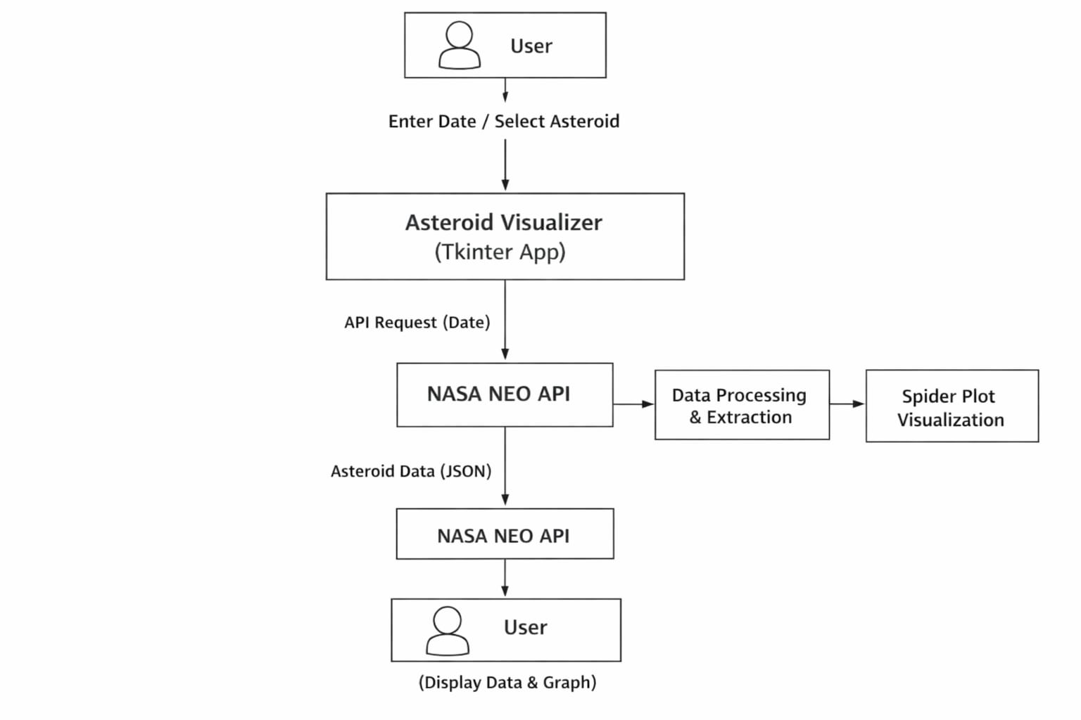

LEVEL 2 DFD:

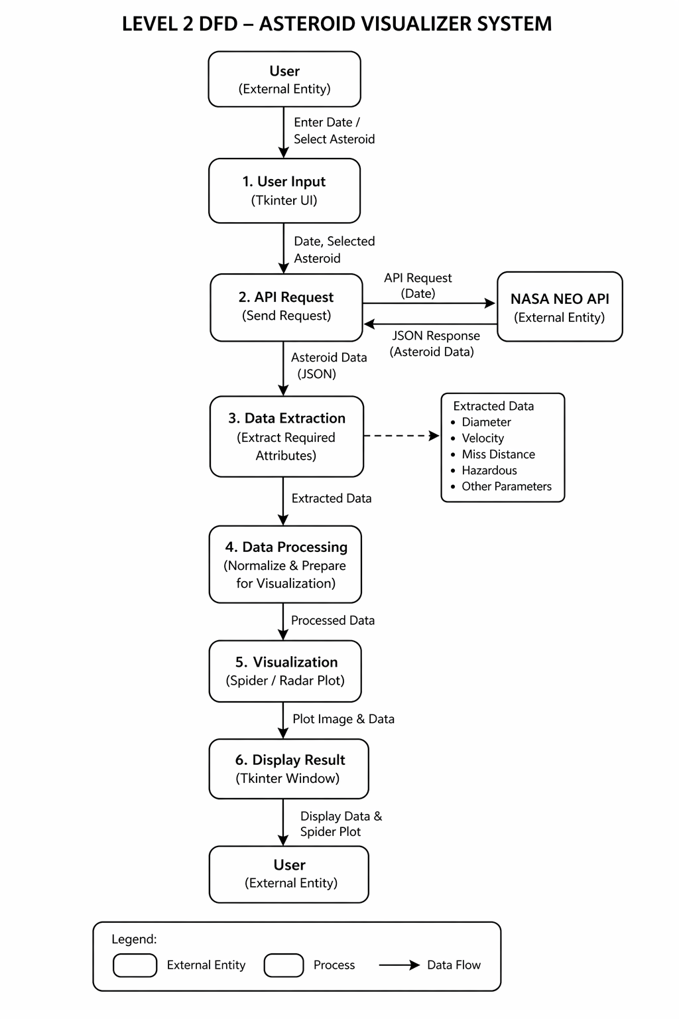

CONTROL FLOW DIAGRAM
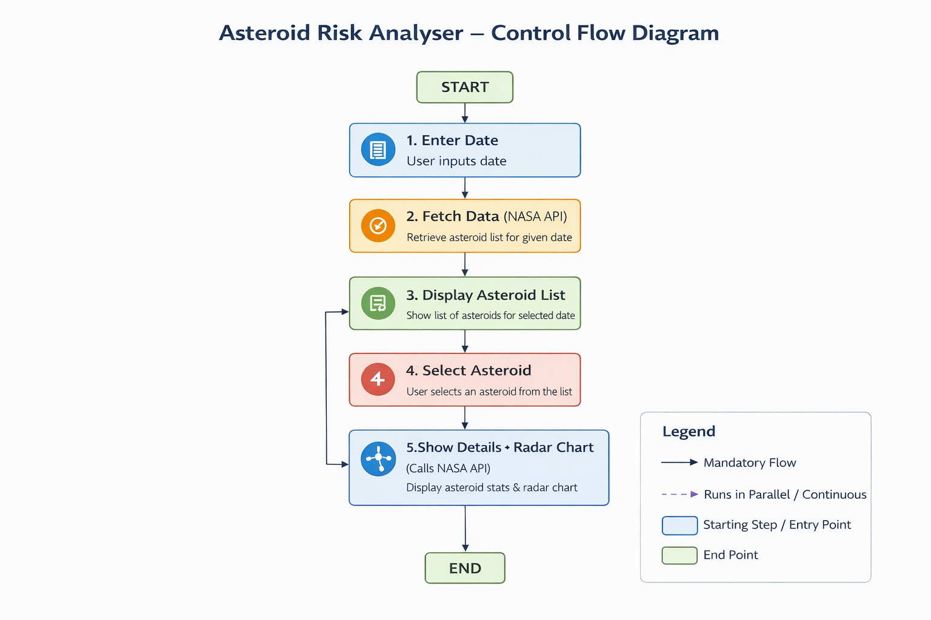

CLASS DIAGRAM
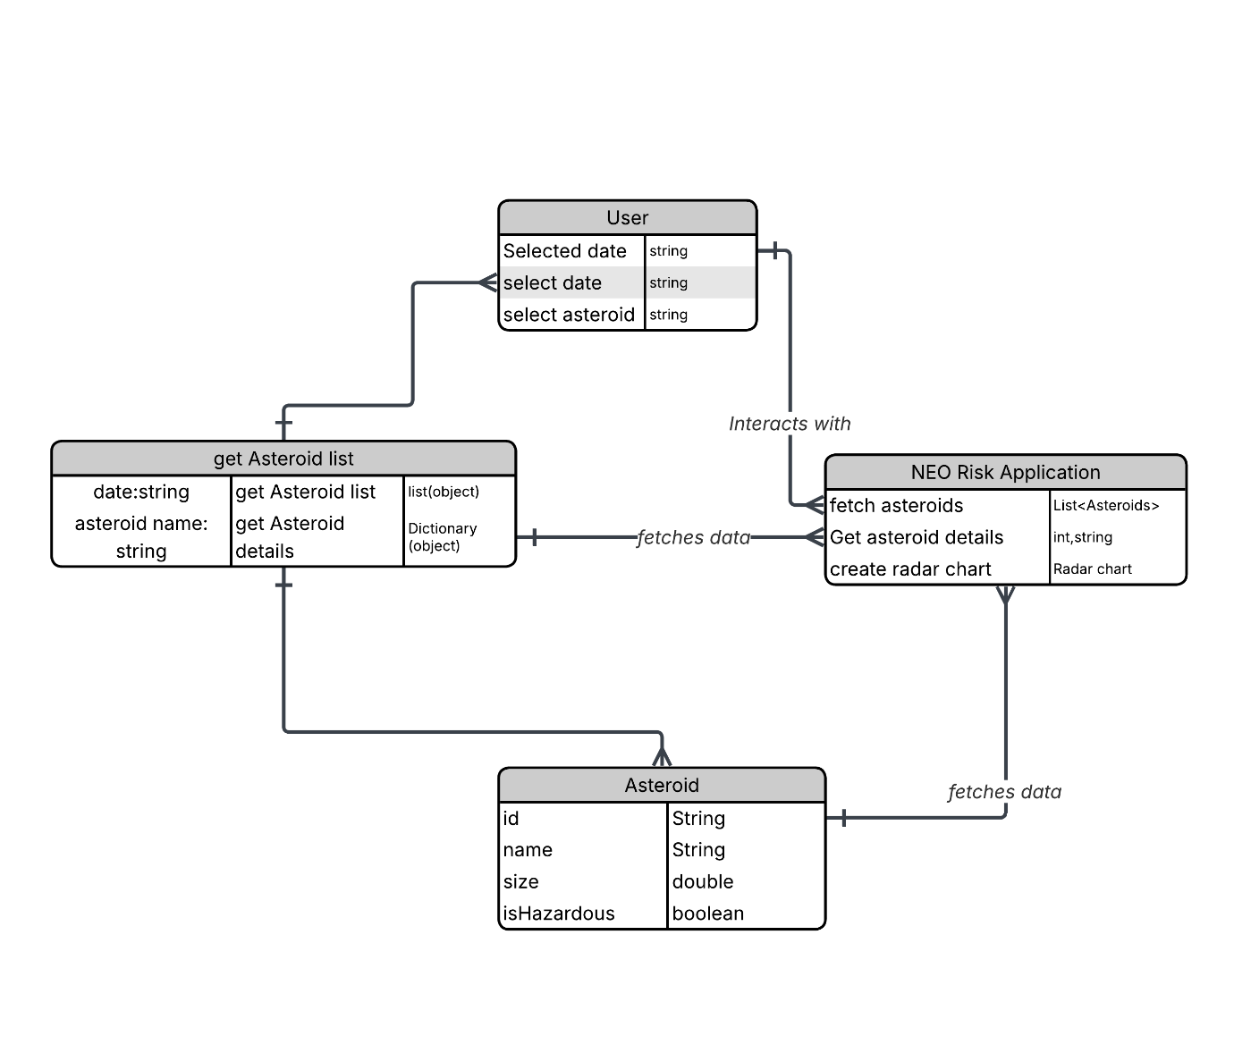

USE CASE DIAGRAM
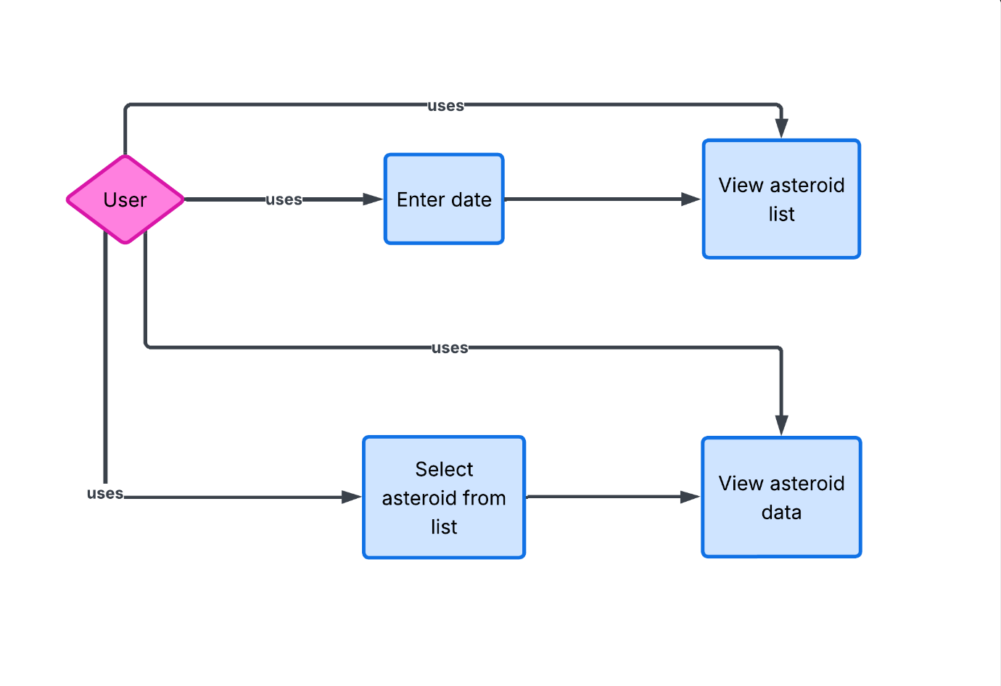

TESTING

Testing Techniques: -
1. Unit Testing
Each module of the application was tested individually:
- API request handling using Requests (Python library)
- Graph generation using Matplotlib and Numpy
- GUI components using Tkinter
This ensured that every function (data fetching, plotting, visualization) works correctly in isolation.
2. Integration Testing
After unit testing, all components were integrated and tested together:
- API data → retrieved → displayed in GUI
- GUI interaction → triggers data visualization (radar chart)
This ensured smooth interaction between backend and frontend interface.
3. System Testing
The complete application was tested as a whole:
- User enters a date
- Application fetches asteroid data from NASA’s NEO API
- Displays asteroid list
- Clicking an asteroid shows full details and radar chart
This verified that the system meets all functional requirements.

4. User Interface (UI) Testing
- Checked button clicks, list selection, and navigation
- Ensured proper display of asteroid details
- Verified readability and layout of radar charts

5. Boundary Value Testing
- Tested edge cases for date input:
  - Past dates
  - Current date (default using datetime module)
  - Invalid formats

6. Error Handling Testing
- Tested behaviour when:
  - No internet connection
  - API fails or returns empty data
  - Invalid user input

Testing Strategies: -
1. Black Box Testing
- Focused on inputs and outputs without considering internal code
- Example:
  - Input: Date → Output: List of asteroids
  - Clicking asteroid → Output: Details + chart
2. White Box Testing
- Internal logic was tested:
  - Data parsing from API response
  - Extractingdata like velocity, diameter, and miss distance
  - Radar chart plotting logic
3. Regression Testing
- After making changes, previously working features were re-tested:
  - API fetch
  - Chart generation
  - GUI responsiveness
4. Performance Testing
- Checked:
  - API response time
  - Chart rendering speed
  - Application responsiveness

FUTURE SCOPE

The current application provides asteroid data visualization using NASA’s NEO API, but it can be expanded into a more advanced space analytics tool. Future scope includes:
- Real-time Monitoring System: Extend the application to continuously track Near-Earth Objects (NEOs) in real time instead of a single date-based query.
- Web-Based Deployment: Convert the desktop application (built using Tkinter) into a web application using frameworks like Flask or Django for global accessibility.
- Mobile Application Development: Develop an Android/iOS version for on-the-go asteroid tracking and alerts.
- Integration with Multiple Space APIs: Combine data from other space agencies to provide richer and more accurate datasets.

Further Enhancements: -
- Add multiple chart types beyond radar charts (line graphs, bar charts) using Matplotlib or advanced libraries
- Use machine learning to predict: potential hazardous asteroids
- Replace basic GUI with modern interface (e.g., PyQt or web UI) and add animations and smoother transitions
- Error message when entered wrong credential.

IMPLEMENTATION (CODE)

import ctypes
ctypes.windll.shcore.SetProcessDpiAwareness(1) #sharpens window
import tkinter as tk
from tkinter import ttk
import requests
import numpy as np
import matplotlib.pyplot as plt
from matplotlib.backends.backend_tkagg import FigureCanvasTkAgg
from datetime import date
API_KEY = "oomEEyKZlhMoqUQy4IWFx4KwUchNhngUoRtJKJT8"
root = tk.Tk() # Create main window
root.title("NEO Risk Analyzer")
root.geometry("1500x900+100+50")
root.resizable(False, False)
root.config(bg="#96b6c5")
#root.iconbitmap("C:\\Users\\HP\\OneDrive\\Desktop\\New folder\\NEO.ico.ico")
top = tk.Frame(root,bg="#fff8f0",height=150,) #top frame
top.pack(side="top", fill='x',pady=(10,10),padx=(10,10))
top.pack_propagate(False)
bleft = tk.Frame(root, bg='#fff8f0', width=500 ,height=800) #bottom_left frame
bleft.pack(side='left', fill='y',padx=(10,10),pady=(0,10))
bleft.pack_propagate(False)
bottom = tk.Frame(root, bg='#050e3c',width=1500,height=600 ) #bottom frame
bottom.pack(side='bottom', fill='x',pady=(10,10),padx=(0,10))
bottom.pack_propagate(False)
mright = tk.Frame(root, bg='#050e3c', width=1500, height=150 ) #middle_right frame
mright.pack(side='left',fill='both',expand=True,padx=(0, 10))
mright.pack_propagate(False)

top.grid_columnconfigure(0, weight=0) #keep frame constant so adding grid won't resize frame
top.grid_columnconfigure(1, weight=0)
top.grid_rowconfigure(1, weight=0)
top.grid_rowconfigure(0, weight=0)
tk.Label(top, text="NEO RISK ANALYZER",font=("Segoe UI", 20, "bold"),bg="#fff8f0",fg="#384959").grid(row=0, column=0,sticky='w',padx=(20,0),pady=(20,10)) #adding data into frame
tk.Label(top, text="Near-Earth Object Threat Detection &Analysis",font=("Segoe UI", 10, "bold"),bg="#fff8f0",fg="#384959",justify='left').pack(side="top",padx=(0, 380), pady=(38,0))
tk.Label(top, text='This application uses NASA’s Near-Earth Object (NEO) API to retrieve real-time asteroid data for monitoring and analyzing impact risks.',font=("Segoe UI", 10, "bold"),bg="#fff8f0",fg="#384959",justify="left",wraplength=800).grid(row=1, column=0,pady=(10,10),padx=(20,0))
tk.Label(bottom, text="Stats graph",font=("Segoe UI", 16, "bold"),bg="#050e3c",fg="white").pack(pady=(20,10))
for i in range(3):
mright.grid_columnconfigure(i, weight=1)
l1=tk.Label(mright, text="Velocity: ", bg="#050e3c", fg="white",font=("Helvetica", 10,"bold")) #adding data into middle_right frame
l1.grid(row=1, column=2, sticky="w",padx=(20,10),pady=(20,10))
l2=tk.Label(mright, text="Id: ", bg="#050e3c", fg="white",font=("Helvetica", 10,"bold"))
l2.grid(row=0, column=0, sticky="w",padx=(10,10),pady=(20,10))
l3=tk.Label(mright, text="Miss_Distance: ", bg="#050e3c", fg="white",font=("Helvetica", 10,"bold"))
l3.grid(row=0, column=1, sticky="w",padx=(10,10),pady=(20,10),)
l4=tk.Label(mright, text="Hazardous: ", bg="#050e3c", fg="white",font=("Helvetica", 10, "bold","italic"))
l4.grid(row=0, column=2, sticky="w",padx=(20,10),pady=(20,10))
l5=tk.Label(mright, text="Max_Diameter: ", bg="#050e3c", fg="white",font=("Helvetica", 10,"bold"))
l5.grid(row=1, column=0, sticky="w",padx=(10,10),pady=(20,10))
l6=tk.Label(mright, text="Min_Diameter: ", bg="#050e3c", fg="white",font=("Helvetica", 10,"bold"))
l6.grid(row=1, column=1, sticky="w",padx=(10,10),pady=(20,10))
l7=tk.Label(bottom, text=" ", bg="#050e3c", fg="white", font=("Helvetica", 16, "bold"))
l7.pack(side='left',pady=(10,450),padx=20)
top.grid_rowconfigure(1, weight=0)
l8=tk.Label(bottom, text=" ", bg="#050e3c", fg="white", font=("Helvetica", 10),wraplength=350)
l8.grid(row=0,column=0,pady=(250,0),padx=20)
l9=tk.Label(bottom, text=" ", bg="#050e3c", fg="white", font=("Helvetica", 10),wraplength=400)
l9.grid(row=1,column=0,pady=(220,0))
tk.Label(bleft, text="Enter Date :",bg='#fff8f0',fg='#384959').grid(row=0,column=0,padx=(10,0),pady=(10,5)) #left_bottom frame
style = ttk.Style()
style.configure(
"Modern.TEntry",
relief="flat"
)
entry=ttk.Entry(bleft,width=15,style="Modern.TEntry", font=("Segoe UI", 10)) #entry search box
today = date.today().strftime("%Y-%m-%d")
entry.insert(0, today) # puts current date in entry box by default yyyy-mm-dd
entry.grid(row=0,column=1,pady=(10,5),padx=(5,10))
listbox = tk.Listbox( #adds listbox into bottom_left frame
bleft,
font=("Segoe UI", 12),
width=500,
bg="#96b6c5", # dark background
fg="#2c2c2c",
selectbackground="#f3f4f4",
selectforeground="black",
activestyle="none", # removes dotted selection box
bd=0, # remove border
highlightthickness=0, # remove focus border
relief="raised"

)
listbox.pack(side='top', fill="y",expand=True, pady=(60, 20), padx=(10, 10))

def on_motion(event): #hover animation
index = listbox.nearest(event.y)
listbox.selection_clear(0, tk.END)
listbox.selection_set(index)
listbox.bind("<Motion>", on_motion)
canvas=None
def get_input(): #gets input from entry box
d = entry.get()
url = f"https://api.nasa.gov/neo/rest/v1/feed?start_date={d}&end_date={d}&api_key={API_KEY}"
response = requests.get(url)
data = response.json()
neo_data = data["near_earth_objects"]
asteroids = neo_data[d]
listbox.delete(0, tk.END)
for asteroid in range(len(asteroids)): #adds data (asteroid names) into listbox
listbox.insert(tk.END, " "+asteroids[asteroid]['name'])
def on_select(event): #gets data from API and makes radar graph
global canvas
if canvas:
canvas.get_tk_widget().destroy()
selected = listbox.get(listbox.curselection())
selected=selected[2:]
for asteroid in range (len(asteroids)): #data extraction
if asteroids[asteroid]['name'] == selected:
a=asteroids[asteroid]
min_dia = a["estimated_diameter"]["meters"]["estimated_diameter_min"]
max_dia = a["estimated_diameter"]["meters"]["estimated_diameter_max"]
# Take first close approach data
approach = a["close_approach_data"][0]
# Miss distance (in lunar distance)
miss_distance = float(approach["miss_distance"]["lunar"])

miss_distancekm=float(approach["miss_distance"]["kilometers"])
# Relative velocity (km/h)
velocity = float(approach["relative_velocity"]["kilometers_per_second"])
# Absolute magnitude (brightness)
magnitude = a["absolute_magnitude_h"]
labels = ["Min Dia", "Max Dia", "Miss Dist", "Velocity", "Magnitude"]

# Values corresponding to labels
values = [min_dia, max_dia, miss_distance, velocity, magnitude]
l1.config(text=f"Velocity: {velocity:.2f} km/s")
l2.config(text="Id: " + a['id'])
l3.config(text=f"Miss_Distance: {miss_distancekm:.2f} km" )
if a['is_potentially_hazardous_asteroid']:
l4.config(text="Hazardous: High Risk", fg="red")
else:
l4.config(text="Hazardous: No Risk", fg="#7fff00")
l5.config(text=f"Max_Diameter: {max_dia:.2f} m")
l6.config(text=f"Min_Diameter: {min_dia:.2f} m")
l7.config(text=f"Name: {selected}")
l8.config(text=This spider plot visualizes normalized asteroid parameters on a 1–10 scale, including velocity, minimum and maximum diameter, miss distance (in lunar distance), and magnitude, enabling effective comparative analysis')
#Making Radar Graph using matplotlib
values.append(values[0])
labels.append(labels[0])
max_val = max(values)
values = [(v / max_val)*10 for v in values]
num_vars = len(labels)
angles = np.linspace(0, 2 * np.pi, num_vars)
fig=plt.figure(figsize=(6, 4))
ax = fig.add_subplot(111, polar=True)
ax.plot(angles, values)

ax.fill(angles, values, alpha=0.1)
ax.set_xticks(angles)
ax.set_xticklabels(labels)
ax.set_yticks([0, 2, 4, 6, 8, 10])
canvas = FigureCanvasTkAgg(fig, master=bottom)
canvas.draw()
canvas.get_tk_widget().pack(side="right",padx=(0,20),pady=(0,50))
listbox.bind("<<ListboxSelect>>", on_select)

# Button to trigger function
btn = tk.Button(bleft,text="Submit",command=get_input,font=("Arial", 7),width=6,height=1,bg="#1abc9c",fg="white",
activebackground="#16a085",
activeforeground="white",
bd=0,
relief="flat",
cursor="hand2",
highlightthickness=0
)
btn.grid(row=0,column=2,pady=(15,10),padx=(0,5))

#color change when clicking on botton
def on_enter(e):
btn.config(bg="#16a085")
def on_leave(e):
btn.config(bg="#1abc9c")
btn.bind("<Enter>", on_enter)
btn.bind("<Leave>", on_leave)
get_input()
root.mainloop() # Run the window

OUTPUT:
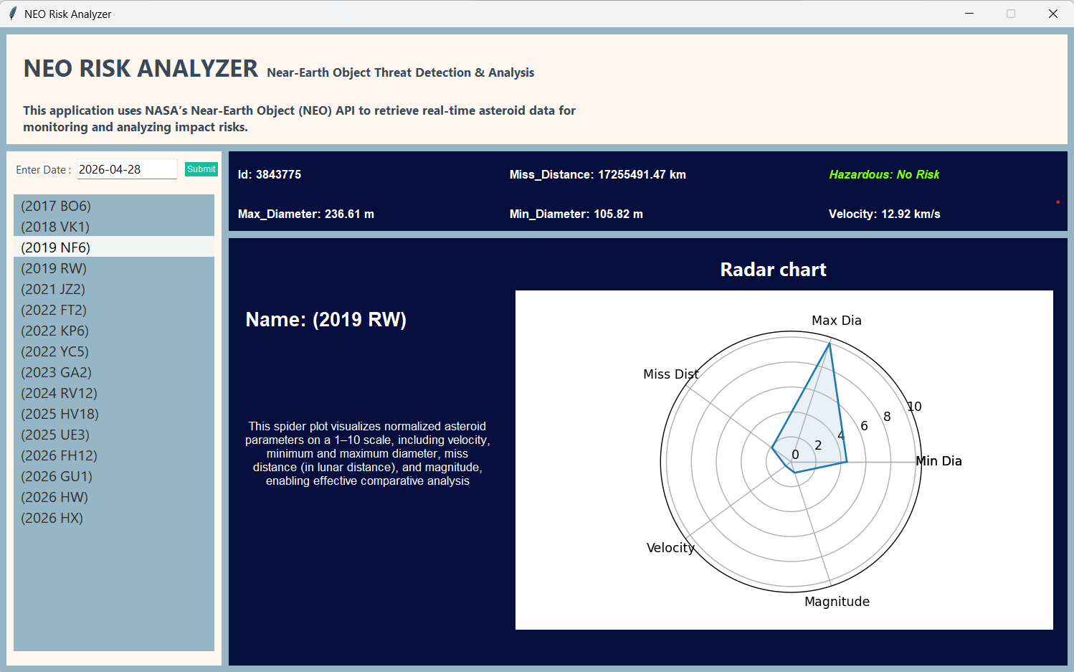

BIBLIOGRAPHY

Web References:
- NASA Near Earth Object (NEO) API Documentation
https://api.nasa.gov/
- Matplotlib Documentation
https://matplotlib.org/stable/index.html
- Tkinter Documentation
https://docs.python.org/3/library/tkinter.html
- W3Schools – Python & API Tutorials
https://www.w3schools.com/
- GeeksforGeeks – Python & Data Visualization
https://www.geeksforgeeks.org/

Research Papers:
- Asteroid Risk Assessment: A Probabilistic Approach – Jason C. Reinhardt, Xi Chen, Wenhao Liu, Petar Manchev, M. Elisabeth Paté-Cornell.
- Impact Probability Computation of Near-Earth Objects using Monte Carlo Simulation – Matteo Romano, Matteo Losacco, Camilla Colombo, Pierluigi Di Lizia.

